**SELF-CARE DESIGN**

**A PROJECT REPORT**

***Submitted by***

***MS.* TEJASWINI KOKANE**

#### In partial fulfillment for the requirement of

**EDUBRIDGE LEARNING COURSE**

***In***

### SOFTWARE TESTING

OCTOBER 2022

## BONAFIDE CERTIFICATE

Certified that this project report **“……….SELF-CARE WEBSITE……………..”** is the bonafide work of “**…………..TEJASWINI KOKANE.…………”** who carried out the project work under my supervision. Certified further that to the best of my knowledge the work reported herein does not form part of any other thesis or dissertation on the basis of which a degree or award was conferred on an earlier occasion on this or any other candidate.

###### SIGNATURE

MOHANA PRIYA

###### SUPERVISOR

**Submitted Project on 17TH OCT 2022**

###### TABLE OF CONTENT

###### TITLE

###### ABSTRACT

###### OBJECTIVE

###### INTRODUCTION

###### 2.1 SELF CARE PROCESS MODEL

###### SOFTWARE REQUIREMENT

###### CODE

###### 4.1 SCREENSHOTS

###### CONCLUSION

**ABSTRACT**

**Objectives**

There is extensive literature from various disciplines on self-care, an important aspect of nursing intervention via evaluation and education, but its meaning remains unprecise due to the difficulty integrating the diverse definitions developed over time across disciplines.

Therefore, it is vital to clarify the meaning of self-care and formulate the defining attributes, antecedents, and consequences to self-care.

**INTRODUCTION**

The World Health Organization defines self-care as the ability of individuals, families and communities to promote, maintain health, and prevent disease and to cope with illness with or without the support of a health care provider. Self-care encompasses several issues including hygiene, nutrition, lifestyle, environmental and socio-economic factors. Promotion of self-care is a means to empower individuals, families and communities for informed health decision-making. It has the potential of improving the efficiency of health systems and contributing towards health equity.

This website is designed to provide essential information related to human body and measures that need to be adopted to preserve and promote health as well as prevent disease. It contains information about what individuals can do themselves when illness strikes. It is an essential tool for community-based health workers and community health volunteers to promote health, prevent and control disease. The information in this website will also be useful for health professionals and the general public for adopting appropriate self-care practices.

**SELF-CARE PROCESS MODEL**

Your Favorite Thing’s

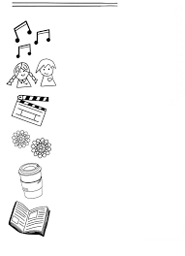

What Balls are you juggling?

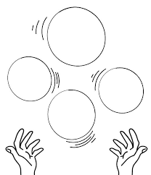

We all have fears. Use the signposts

To name yours

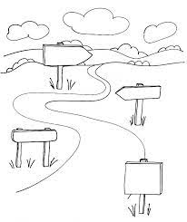

Name the boxes below to describe yourself

In 10 positive words

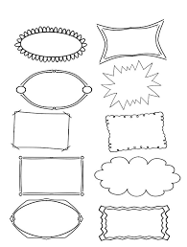

**SOFTWARE REQUIREMENT**

**Notepad**

Windows Notepad is a simple text editor for Windows; it creates and edits plain text documents.

**Front End**

HTML, CSS, JavaScript are utilized to implement the frontend.

* HTML: HTML stands for **Hyper Text Markup language** is the standard markup language for creating Web pages.
* CSS: CSS stands for **Cascading Style Sheets**. It Describes how HTML elements are to be displayed on screen, paper, or in other media.
* JavaScript: An object oriented programming language commonly used to create interactive effects within web browsers.

**CODE**

**Self-Care Page**

<!DOCTYPE html>

<head>

<title>Self Care - Journal</title>

<meta charset="UTF-8">

<meta name="viewport" content="width=device-width,initial-scale=1.0">

</head>

<body>

<header>

<a href="SelfCare.html">

<img src="C:\Users\DELL\Desktop\Paint self care.png" alt="Self-Care" title="Self Care-Love every inch of yourself">

</a>

</header>

<hr>

<nav>

<table cellspacing="5" cellpadding="5">

<tr>

<td><a href=SelfCare.html>Home</a></td>

<td><a href=Habits.html>Habits</a></td>

<td><a href=Quotes.html>Quotes</a></td>

<td><a href=Books.html>Books</a></td>

</tr>

</table>

</nav>

</hr>

<h2 id="top"></h2>

<h2>Welcome - Well-Being & Self-Care!</h2>

<p>"Self-Care is the necessity to do things that are good for our physical ,emotional, or physchological well-being"

</P>

<img src="C:\Users\DELL\Downloads\1662575849311.jpg" width="100%" height="100%"

title="A place or Environment where I feel Confident." >

<p style ="color:Tomato"><Strong>WHEN IN DISTRESS, USE MY SAFE SPACE TO DE-STRESS!</Strong></p>

<ol>

<li>“Until you value yourself, you won’t value your time. Until you value your time, you will not do anything with it.”— M. Scott Peck</li>

<li> “You have to believe in yourself when no one else does—that makes you a winner right there.”— Venus Williams </li>

</ol>

<p ><Strong>Self Care Practices</Strong></p>

<ul>

<li>"Physical Self-care is taking care of your body."</li>

<li>"Mental Self-care starts with paying attention to how you talk to yourself."</li>

<li>"Emotional Self-care is about understanding your emotions."</li>

<li>"Spritual Self-Care is about connecting to the fact that your life has meaning and persuing your passion."</li>

<li>"Social Self-Care involves speding time with people you enjoy ."</li>

<li>"Financial Self-Care includes budgeting, Financial planning and managing Dept."</li>

</ul>

<br>

<p><h3>Customer reviews</h3></p>

<p>30 global ratings</p>

5 star:

<meter value="8" min="0" max="10"></meter><br>

4 star:

<meter value="6" min="0" max="10"></meter><br>

3 star:

<meter value="4" min="0" max="10"></meter><br>

2 star:

<meter value="2" min="0" max="10"></meter><br>

1 star:

<meter value="2" min="0" max="10"></meter><br><br>

<p><strong>Made With Love</strong></p>

<hr>

<footer>

<a href="https://www.youtube.com">

<img src="C:\Users\DELL\Desktop\EduBridge\Software Testing\Project\Link.png" title ="Go to Self-care Youtube chanel !"></a>

<br>

copyright &copy; SelfCare.love 2022-2023

</footer>

<p><a href="#top"> top of the page</a></p>

</body>

Screenshots:

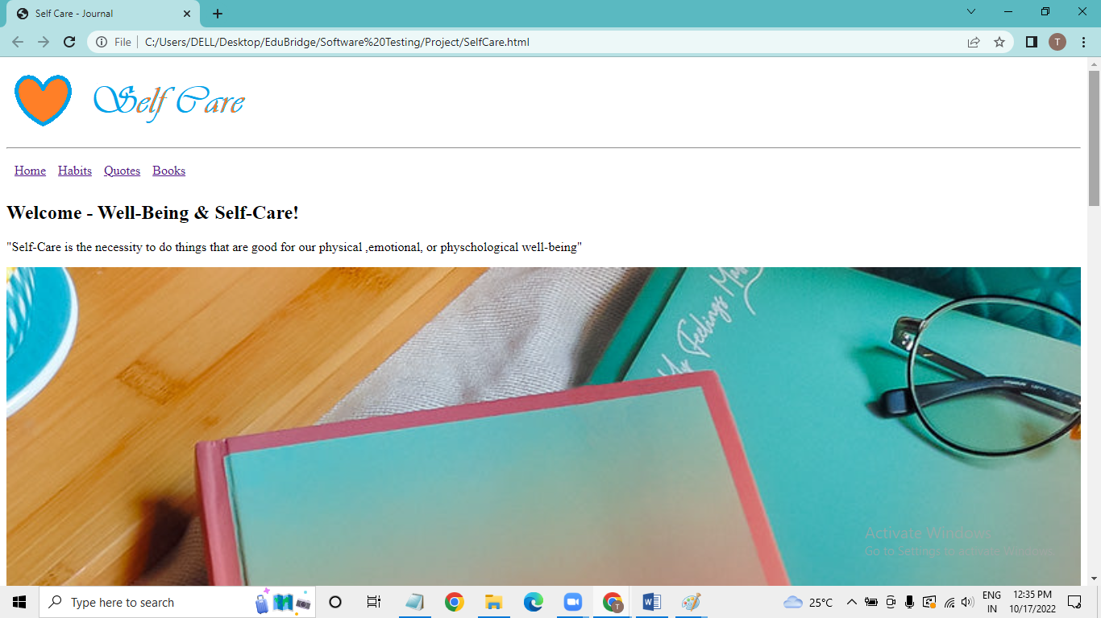

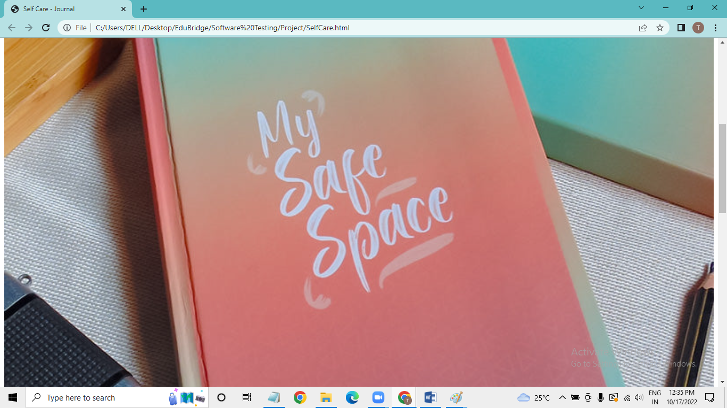

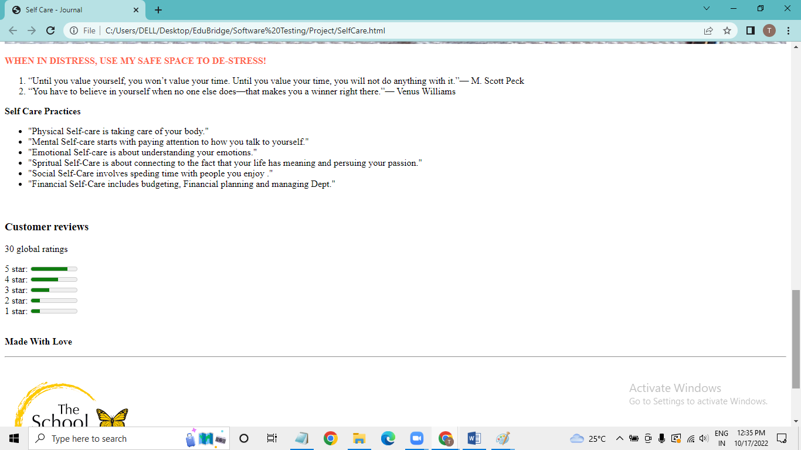

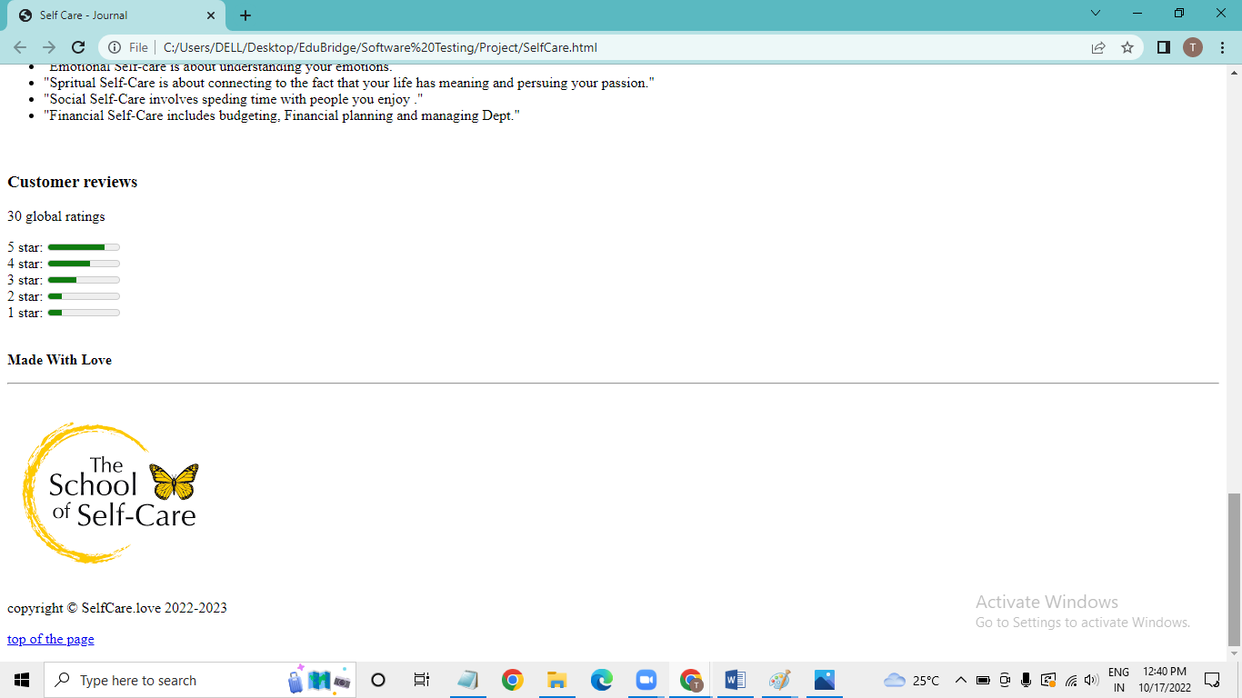

Habits Page

<!DOCTYPE html>

<head>

<title>Habits</title>

<meta charset="UTF-8">

<meta name="viewport" content="width=device-width,initial-scale=1.0">

</head>

<body>

<header>

<a href="SelfCare.html">

<img src="C:\Users\DELL\Desktop\Paint self care.png" alt="Self-Care" title="Self Care-Love every inch of yourself">

</a>

</header>

<body >

<hr>

<nav>

<table cellspacing="5" cellpadding="5">

<tr>

<td><a href=SelfCare.html>Home</a></td>

<td><a href=Habits.html>Habits</a></td>

<td><a href=Quotes.html>Quotes</a></td>

<td><a href=Books.html>Books</a></td>

</tr>

</nav>

</table>

<hr>

<h2>Habits</h2>

<img src="C:\Users\DELL\Desktop\EduBridge\Software Testing\Project\Habit.jpg" >

<br>

<section>

<h4>Do Something Just for Fun</h4>

<p>Crank up the music and dance. Laugh with your kids. Play a game. Write. Buy flowers. Follow your passions. Attend a fun event. The real <abbr title="Return on Investment">ROI</abbr>? A better, more energized, happier self.</p>

</section>

<section>

<h4>Be Adventurous</h4>

<p>Get outside your comfort zone. Be brave. Challenge yourself. Whether that be a backpacking trip, trying a new activity, or pushing yourself physically, mentally or emotionally, you’ll feel proud, confident and strong.</p>

</section>

<section>

<h4>Treat Yourself and Your Body</h4>

<p>When you look good, you feel good. Get a haircut, have your nails done, enjoy a facial, manicure or pedicure. When we take care of how we look physically, we feel better emotionally. </p>

</section>

<section>

<h4>Spend Time with Those You Love</h4>

<p>Schedule a date night with your partner, a special day with your kiddo or happy hour with your BFF. Studies prove that people who socialize often have higher levels of happiness. This doesn’t have to be face-to-face; sometimes a phone call is all you need (and can fit in!). </p>

</section>

<section>

<h4>Express Gratitude</h4>

<p> In order to live a life we love, we must first love the life we live. Research continues to surface on the science and benefits of gratitude. Being grateful is one of the simplest, yet most powerful, things you can do to take care of yourself.</p>

</section>

<br>

<hr>

<video width="500" height="450" controls>

<source src="C:\Users\DELL\Desktop\EduBridge\Software Testing\Project\video.mp4" type="video/mp4">

</video>

<h4>About Good habits - Eat good Feel good</h4>

<br>

<br>

<hr>

<footer>

<a href="https://www.youtube.com">

<img src="C:\Users\DELL\Desktop\EduBridge\Software Testing\Project\Link.png" title ="Go to Self-care Youtube chanel !"></a>

<br>

copyright &copy; SelfCare.love 2022-2023

</footer>

</body>

Screenshots:

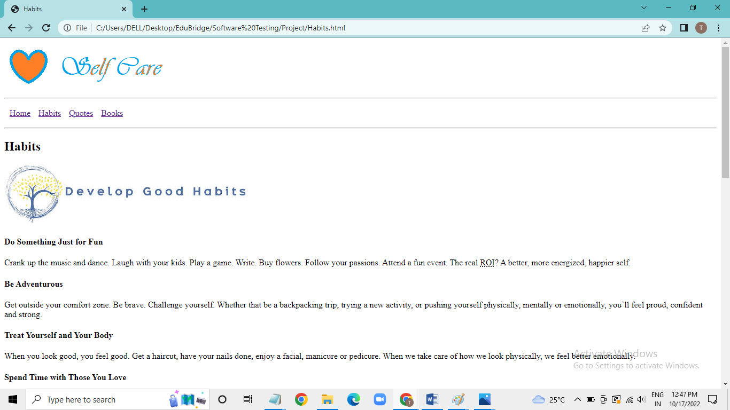

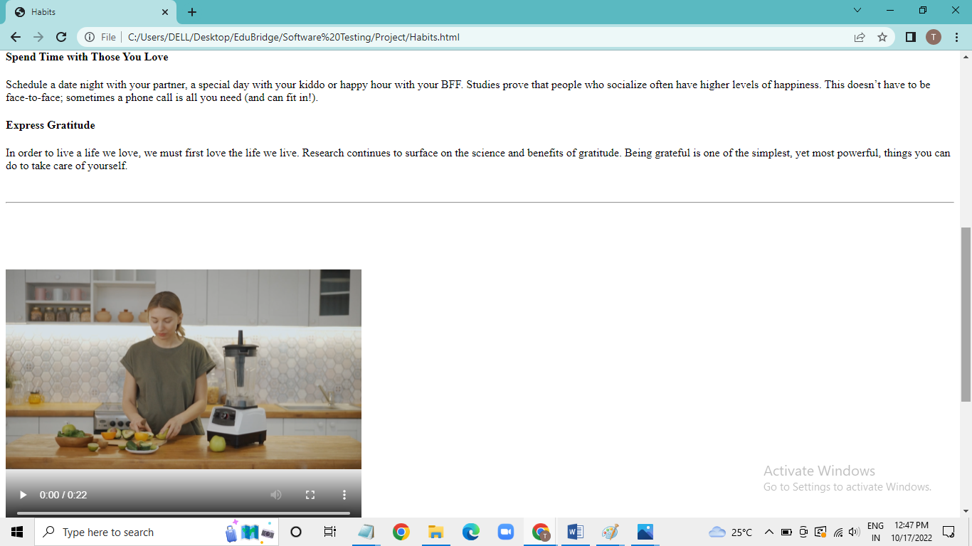

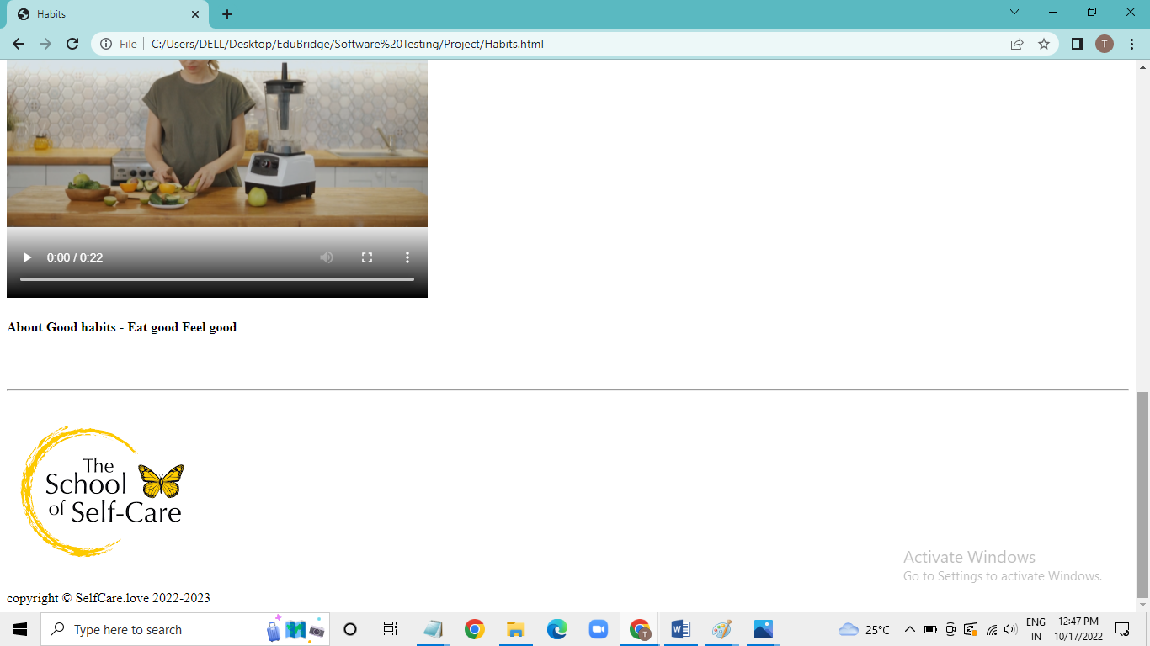

Quotes Page:

<!DOCTYPE html>

<head>

<title>Quotes</title>

<meta charset="UTF-8">

<meta name="viewport" content="width=device-width,initial-scale=1.0">

</head>

<style>

aside {

width: 30%;

padding-left: 30px;

margin-left: 30px;

float: right;

font-style: italic;

background-color: lightgray;

}

</style>

<style>

table,

th,

td {

border: 1px solid black;

border-collapse: collapse;

padding: 15px;

cellspacing="5";

cellpadding="5";

}

</style>

</head>

<body >

<header>

<a href="SelfCare.html">

<img src="C:\Users\DELL\Desktop\Paint self care.png" alt="Self-Care" title="Self Care-Love every inch of yourself">

</a>

</header>

<hr>

<nav>

<table cellspacing="5" cellpadding="5">

<tr>

<td><a href=SelfCare.html>Home</a></td>

<td><a href=Habits.html>Habits</a></td>

<td><a href=Quotes.html>Quotes</a></td>

<td><a href=Books.html>Books</a></td>

</tr>

</nav>

</table>

<hr>

<h2>Quotes</h2>

<img src="C:\Users\DELL\Desktop\EduBridge\Software Testing\Project\Quotes.png" >

<br>

<br>

<br>

<table>

<tr>

<th >Paraphase</th>

<th>Epigrammatist</th>

</tr>

<tr>

<th >“Talk to yourself like you would to someone you love.”</th>

<th>Brene Brown</th>

</tr>

<tr>

<th >“Self-discipline is self-caring.”</th>

<th>M.Scott Peck</th>

</tr>

<tr>

<th >“Adopt the pace of nature: her secret is patience.”</th>

<th>Ralph Waldo Emerson</th>

</tr>

<tr>

<th >“Be faithful to that which exists within yourself.”</th>

<th>Andre Guide</th>

</tr>

</table>

<aside>

<h1 id="Folk">Hi Folk!</h1>

<p>I'm Tejaswini Kokane</p>

<br>

<p>Since 2022 I've Written about Self esteem and Happiness and much more.</p>

</aside>

<br>

<br>

<p style ="color:Tomato"><Strong>Sound that bring you comfort and connection</Strong></p>

<audio controls>

<source src="C:\Users\DELL\Desktop\EduBridge\Software Testing\Project\Audio.mp3" type="audio/mpeg" type="audio/mp3">

</audio>

<hr>

<footer>

<a href="https://www.youtube.com">

<img src="C:\Users\DELL\Desktop\EduBridge\Software Testing\Project\Link.png" title ="Go to Self-care Youtube chanel !"></a>

<br>

copyright &copy; SelfCare.love 2022-2023

</footer>

</body>

Screenshots:

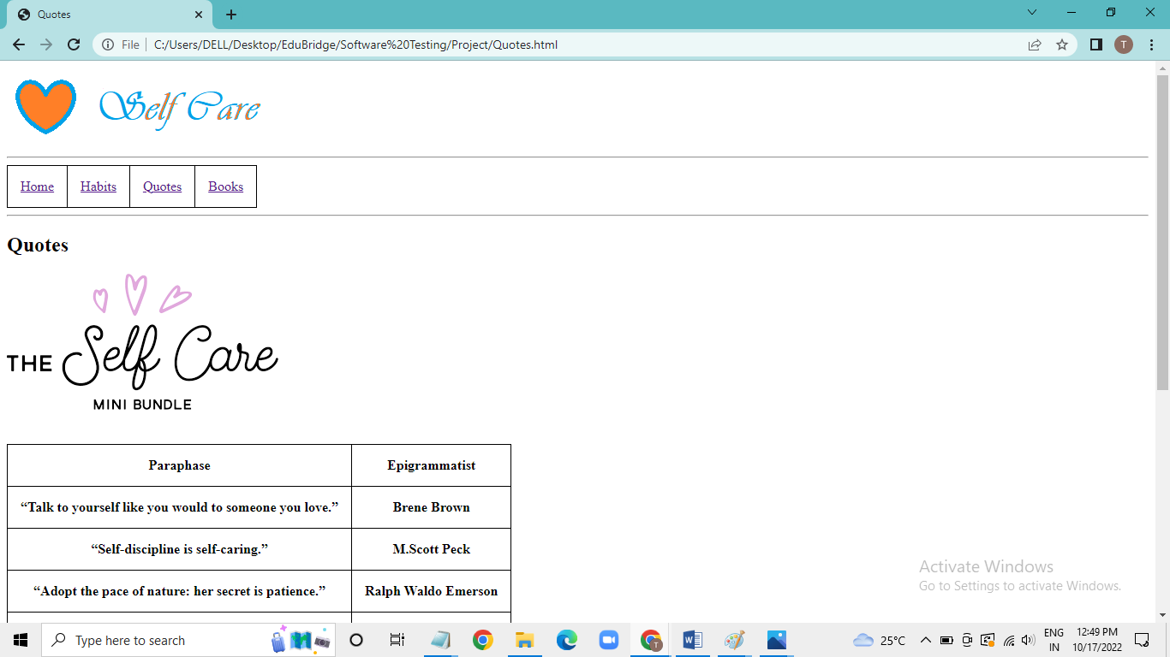

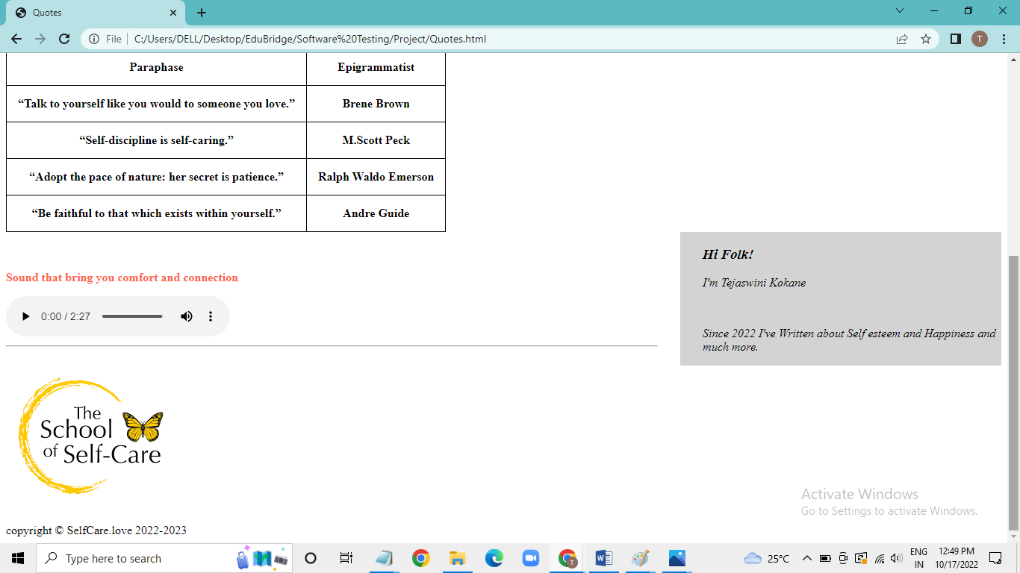

Books Page:

<!DOCTYPE html>

<head>

<title>Books</title>

<meta charset="UTF-8">

<meta name="viewport" content="width=device-width,initial-scale=1.0">

</head>

<body>

<header>

<a href="SelfCare.html">

<img src="C:\Users\DELL\Desktop\Paint self care.png" alt="Self-Care" title="Self Care-Love every inch of yourself">

</a>

</header>

</header>

<hr>

<nav>

<table cellspacing="5" cellpadding="5">

<tr>

<td><a href=SelfCare.html>Home</a></td>

<td><a href=Habits.html>Habits</a></td>

<td><a href=Quotes.html>Quotes</a></td>

<td><a href=Books.html>Books</a></td>

</tr>

</nav>

</table>

<hr>

<table cellpadding="10">

<tr>

<td valign="top" width="15%">

<img src="C:\Users\DELL\Desktop\EduBridge\Software Testing\Project\Book1.jpg" width="100%" height="100%">

</td valign="top">

<td>

Your Second Life Begins When You Realize You Only Have One: The novel that has made over 2 million readers happier.THE INTERNATIONAL BESTSELLER: 2 million copies sold worldwide! A charming, feel-good and universal story of one woman’s journey from boredom and dissatisfaction to happiness and fulfilment.Random House presents the audiobook edition of Your Second Life Begins When You Realize You Only Have One by Raphaelle Giordano, read by Fiona Hardingham.

</td>

</tr>

<tr>

<td valign="top" width="15%">

<img src="C:\Users\DELL\Desktop\EduBridge\Software Testing\Project\Book2.jpg" width="100%" height="100%">

</td valign="top">

<td>

The Comfort Book

by Matt Haig

From the bestselling author of The Midnight Library, Matt Haig offers warmth and reassurance, reminding us to slow down and appreciate the beauty and unpredictability of existence. An essential book for anyone in search of hope, looking for a path to a more meaningful life, or in need of a little encouragement.

</td>

</tr>

<tr>

<td valign="top" width="15%">

<img src="C:\Users\DELL\Desktop\EduBridge\Software Testing\Project\Book3.jpg" width="100%" height="100%">

</td valign="top">

<td>

You’ve probably heard phrases like, “You can’t love anyone else until you love yourself” and “You can’t take care of anyone else until you’ve taken care of yourself.” These phrases are grounded in truth.Boost your confidence to live an authentic life in line with your values;- Expand your self-worth & feel at ease saying ‘No’ to things that don’t serve you.This Self-Love Workbook for Women is perfect for any woman and promotes gratefulness, mindfulness, positivity, self-care, self-compassion, and self-love!

</td>

</tr>

<tr>

<td valign="top" width="15%">

<img src="C:\Users\DELL\Desktop\EduBridge\Software Testing\Project\Book4.jpg" width="100%" height="100%">

</td valign="top">

<td>

You’ve probably heard phrases like, “You can’t love anyone else until you love yourself” and “You can’t take care of anyone else until you’ve taken care of yourself.” These phrases are grounded in truth.Boost your confidence to live an authentic life in line with your values;- Expand your self-worth & feel at ease saying ‘No’ to things that don’t serve you.This Self-Love Workbook for Women is perfect for any woman and promotes gratefulness, mindfulness, positivity, self-care, self-compassion, and self-love!

</td>

</tr>

</table>

<br>

<br>

<hr>

<h3><Strong>Do you have any feedback for us?</Strong></h3>

<br>

<form>

<fieldset>

<legend>Personal Details</legend>

<p>

<label>

Salutation

<br />

<select name="salutation">

<option>--None--</option>

<option>Mr.</option>

<option>Ms.</option>

<option>Mrs.</option>

<option>Dr.</option>

<option>Prof.</option>

</select>

</label>

</p>

<p>

<label>First name: <input name="firstName" /></label>

</p>

<p>

<label>Last name: <input name="lastName" /></label>

</p>

<p>

Gender :

<label><input type="radio" name="gender" value="male" /> Male</label>

<label><input type="radio" name="gender" value="female" /> Female</label>

</p>

<p>

<label>Email:<input type="email" name="email" /></label>

</p>

<p>

<label>Date of Birth:<input type="date" name="BirthDate"></label>

</p>

<p>

<label>

Give us a review:

<br />

<textarea name="Give us a review" cols="30" rows="3"></textarea>

</label>

</p>

<p>

<!--<button type="submit">Submit</button>-->

<button onclick="alert('Hey, thanks for the feedback.')">Submit</button>

</p>

</fieldset>

</form>

<br>

<br>

<hr>

<footer>

<a href="https://www.youtube.com">

<img src="C:\Users\DELL\Desktop\EduBridge\Software Testing\Project\Link.png" title ="Go to Self-care Youtube chanel !"></a>

<br>

copyright &copy; SelfCare.love 2022-2023

</footer>

</body>

Screenshots:

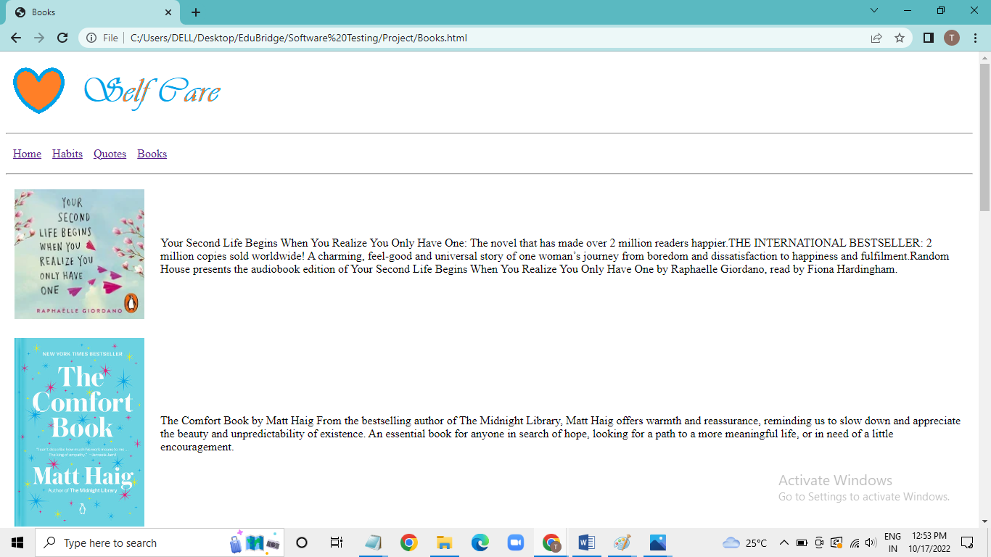

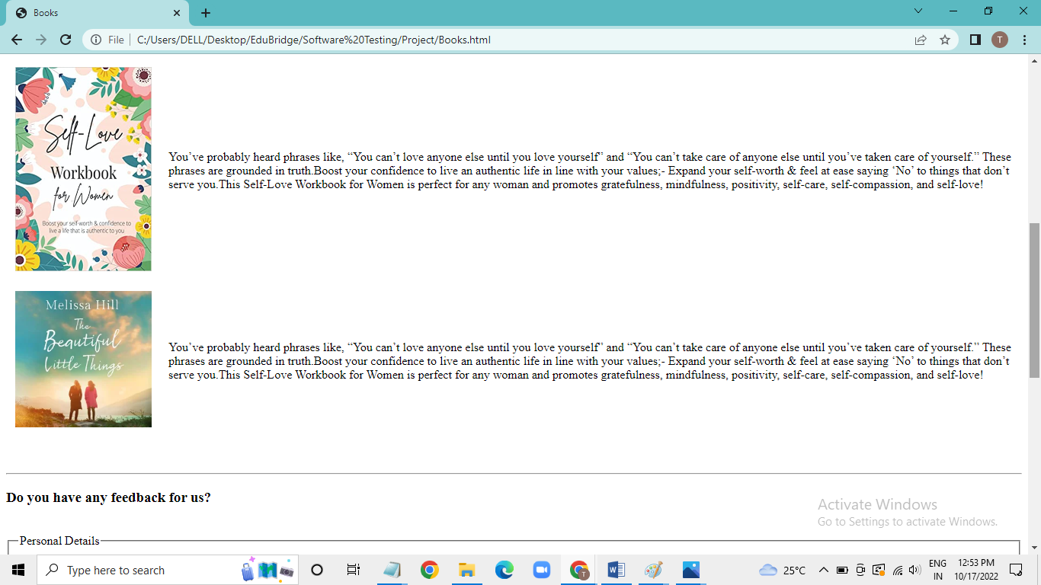

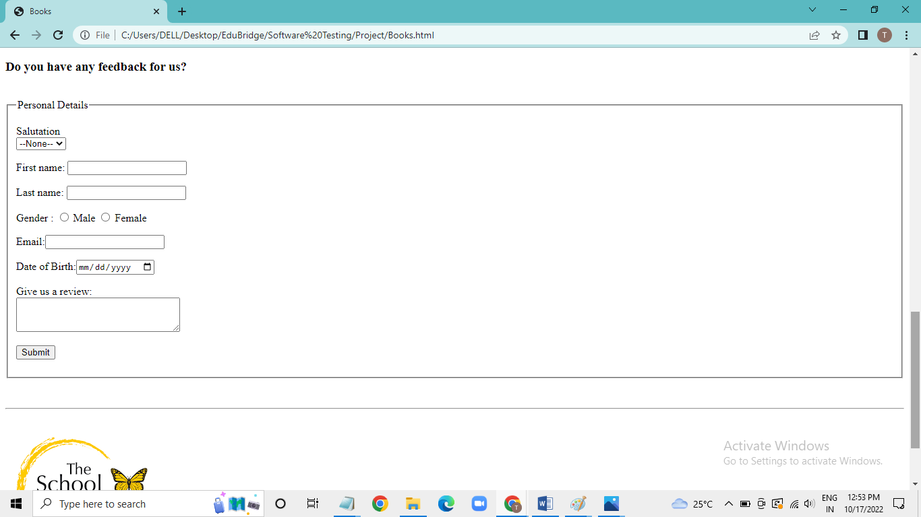

**CONCLUSION**

1. See the letter Q, I think of quotes. I am always a big fan of having inspirational words, quotes, mottos in my life to keep me motivated and to remind me of the important things in life.
2. R is for reading. Many students at Hopkins are overloaded with work and readings for class. Changing that up and reading a book just for pure enjoyment can be a great way to care for yourself and do something you enjoy.
3. Organize is for O. Do it any way you want, but organizing yourself is a great way to make sure that your self-care is firmly part of your schedule.
4. For S, I think of seeking support. Asking for help can be really really tough. People will often do this in all kinds of ways, like making a joke about it, hoping someone will notice. Everyone needs help for something or other at some point in time. There is no shame in that.
5. T is talking. My mum always told me that a problem shared is a problem halved and I still believe that to this day. Talking to someone can be an amazing way to take care of yourself.